ECE 511: Advanced Analogs Electronic

Final Project

Design of a switch-mode power supply (SMPS)

By

Adegbesote Abel A.

Instructor

Dr. Vogt, Timothy

cid:image001.png@01CDFEEE.BA68BBF0

Department of Electrical and Computer Engineering

St. Cloud State University

St. Cloud, MN

Fall 2020

I – Objective:

The purpose of this project is to design and build a switch-mode power supply (SMPS). It also involved sizing and selection of the proper components to meet the required specifications of the SMPS and lastly preparing a bill of material for purchase of components to be used from Digit Key.

II – Calculations:

The main objective is to end up with: 𝑉O=6𝑉, 𝐼O=1.2𝐴

Voltage received from the outside transformer is approximately:

𝑉𝑠=34𝑉; 𝑓=60𝐻𝑧

The voltage ripple s determined to be 2%. The switching frequency is assumed to be 𝑓=250𝑘𝐻𝑧 and the value of Δ𝑖𝐿 assume to be 30% of 𝐼O.

Δ𝑖𝐿 = 0.3*1.2 = 0.36A

The max Inductor current will then be;

ILmax = IL + (Δ𝑖𝐿 / 2)

= 1.2 + 0.18

= 1.38A

Based on the

Using Vo and Vs, the duty cycle can be calculated as follows:

𝐷= 𝑉O / 𝑉𝑠 = 6𝑉 / 34𝑉= 17.6%

The inductor value can be found by using the following:

𝐿= Vo (1−𝐷) /Δ𝑖𝐿∗𝑓 = (6𝑉) (1−0.176) / (0.36𝐴) (250𝑘𝐻𝑧) = 55μH

Using the assumptions above, the capacitors can be found using:

𝐶= (1−𝐷) /8𝐿𝐶𝑓2 (2%) = (1−0.176) / 8* (55μ𝐻) *(250𝐾𝐻𝑧)2 *(0.02) = 1000μF

Load Resistance: R= Vo / Io = 6 / 1.2 = 5 Ohms

III – Simulation procedure:

The SMPS design in this project is the Buck (step down) converter. Here are the components used to complete the design:

* A transformer 110V/24V
* A Line filter: FPP2 – 45, 0.5 - 4A @ Ta 40 °C / 125/250 VAC; 60 Hz.
* A full bridge rectifier: 4 diodes, 1N5819. Forward Voltage (IF = 1.0A), VFM = 600mV, Reverse Voltage = 40V
* A Power factor correction circuit, valley – fill circuit
* A Step down switching regulator (LT1076CT):
* Load resistor: 5Ω

a) – Transformer:

The input AC voltage is supplied by the transformer (F8-48) having the rating 110Vrms/24Vrms, 2A that will step down the 110Vrms to 24Vrms. The Transformer was Model in LT Spice has shown below;

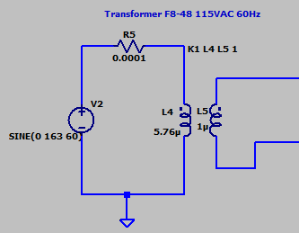

b) – Line filter:

The line filter protect against interference voltage and other AC noise from the mains. Interferences generated in the equipment are strongly attenuated. The line filter rating used is FPP-02 125/250VAC, 4A and the internal circuit has stated in its datasheet is modelled in Ltspice has shown below;

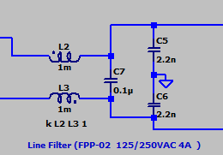

c) – Bridge Rectifier:

The bridge rectifier turns the alternating voltage (AC) into direct voltage (DC). The choice of diode used was based on the project specification requirments. Since the supply voltage is around 34V it is best to select a diode that has an higher breakdown volt of 40V. 1N5819 shottky diode was used which has a rating; Forward Voltage (IF = 1.0A), VFM = 600mV, Reverse Voltage = 40V. The LTSpice model of the bridge rectifier is shown below;

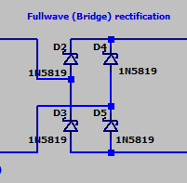

d) – The valley – fill circuit:

This is a type of power factor correction that is used. It will improve the power factor of the circuit by futher raising the Initial voltage higher so it draws more voltage from the source. The image below shos the LTSpice modelling of the valley- fill power factor correction.

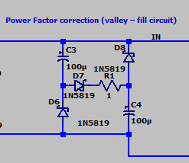

e) – The step down (Buck) switching regulator:

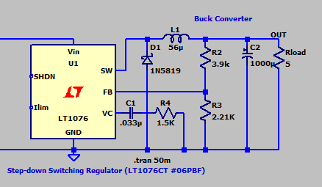

f) – Entire modelling of the SMPS put together in LTSpice:

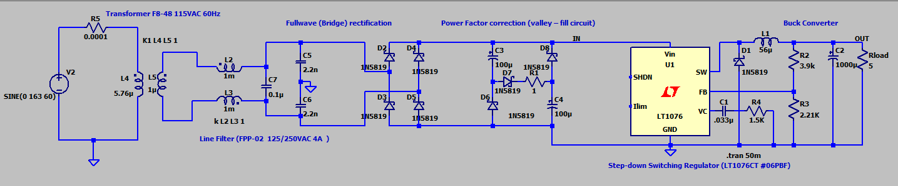

After a succcessful design, here are the measurement of the output voltage of the valley-fill power factor correction circuit, the load output voltage and current in the circuit, .

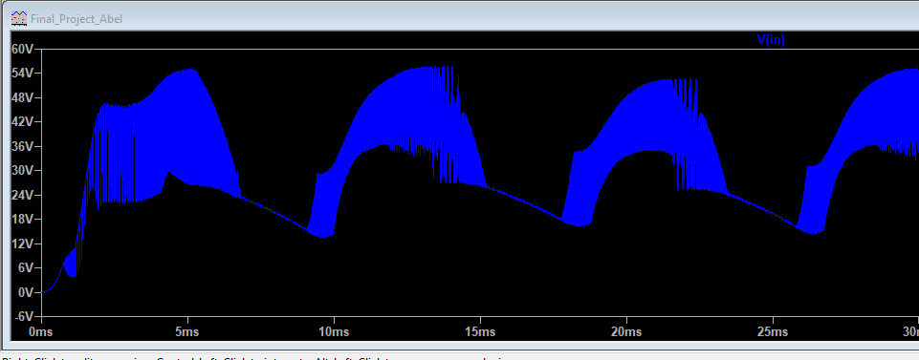

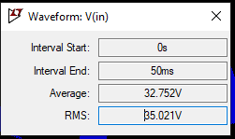

Figure 2: Output voltage of the valley-fill circuit.

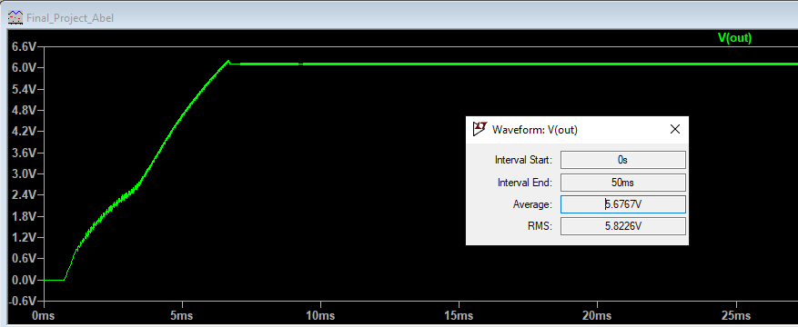

Figure 3: Output voltage of the load.

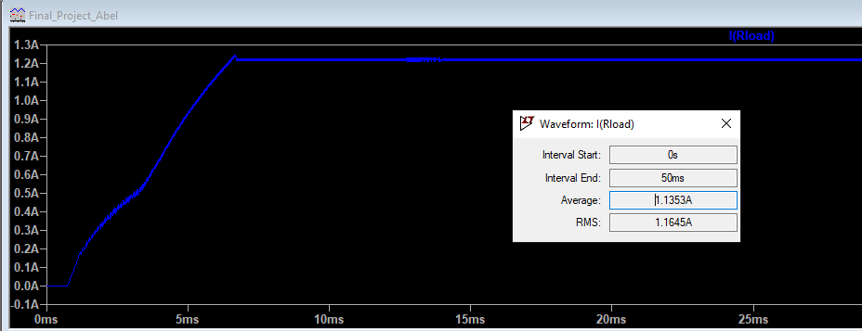

Figure 4: Output current of the load.

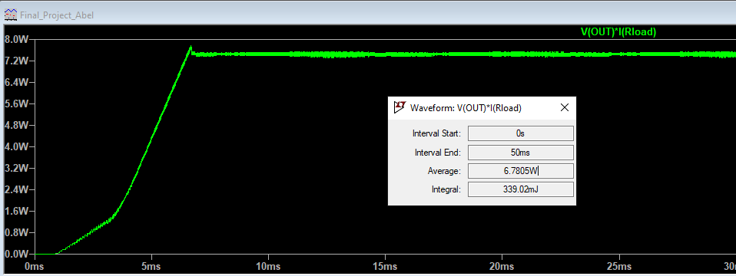

Figure 5: Output power of the load.

e) – Discussion:

The value of the average power and the apparent power are used to calculate the power factor:

pf = VI / Pavg

pf = (5.6767 x 1.1353)/6.7805

pf = 0.9505

pf = 0.95(Approx.)

The output ripple voltage is measured as shown below;

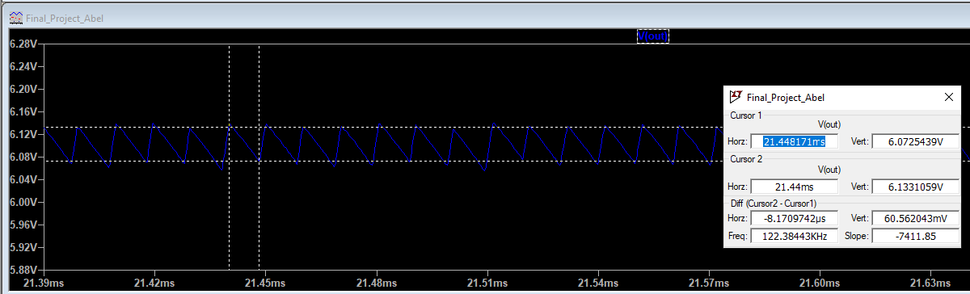

ΔVo/Vo = 0.06056/5.6767

ΔVo/Vo = 1.1%

III – Experimental procedure:

To complete the experimental design, parts were order from Digit key such as: line filter, a step down switching regulator, and an inductor. The circuit was built the exact same way as in the simulation. The bill of material for purchase is provided in procument part 6 (VI) after conclusion below.

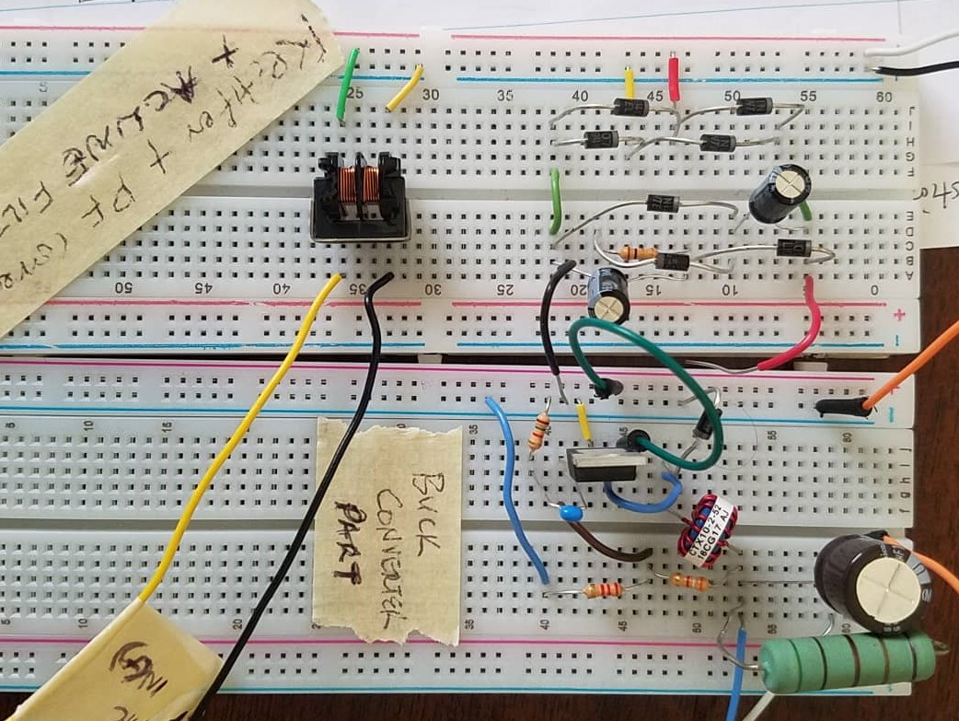

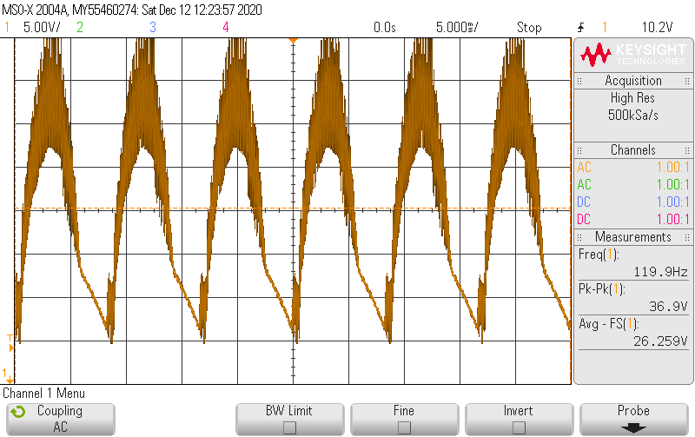Picture 1: Experimental design

Picture 2: Output voltage of the valley-fill circuit.

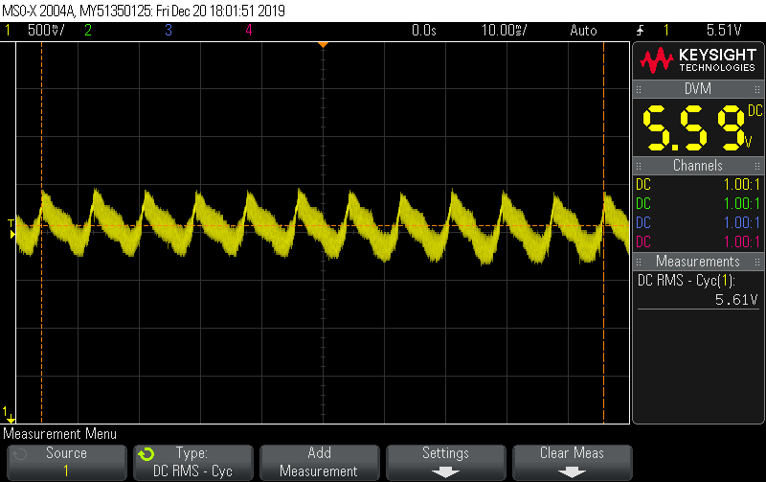

Picture 3: Output voltage of the load.

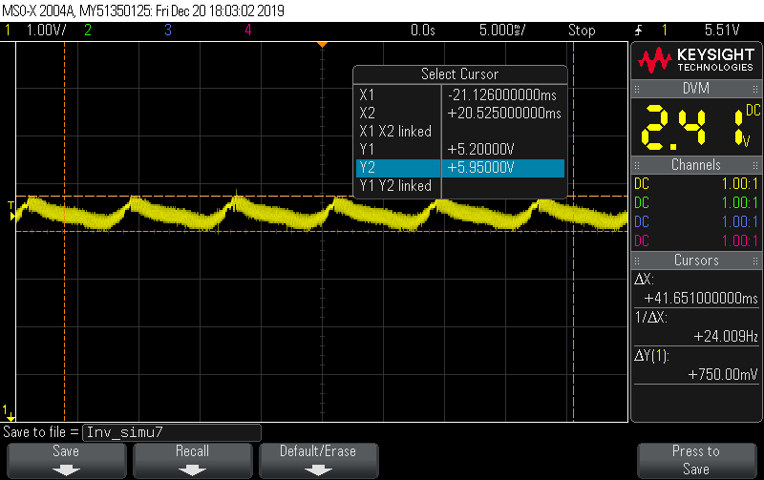

Picture 4: Output voltage ripple of the load.

IV – Discussion:

Again, everything got build exactly the same way as in the simulation. The waveform of the output of the valley – fill circuit when seen in the oscilloscope behaved exactly as expected and was similar to that of the simulation. The troubleshooting was done upstream and downstream of each network without anything that will explain such result in the experimental design. One thing that was noted was that testing the Load with a 5Ohms (10W), the load resistor becomes hot due to the power dissipated due to the current. Also the hot temperature of the LT1076CT chip, this caused switching (on and off) in the output voltage. The ripple output voltage was quite bigger than the one obtained in simulation:

ΔVo/Vo = 0.750/5.61

ΔVo/Vo = 13.4%

V – Conclusion:

The purpose of this laboratory assignment was to design and build a switch mode power supply. This power supply delivered 6.77W / 1.2A to a 5Ω resistor. The components specification in the circuits where chosen and calculated based on the specification of the input voltage supply and the load. The discrepancy in the output voltage could be due many reasons such as reading error from the oscilloscope, losses in the each of the components and losses in the wire connection from the breadboard to the measurement devices. In the end, we conclude that our experiment was successful thus, the difference between the simulation value and the implementation value are in the scale of 11.6%.

VI – Procument (Bill of Material):

|  |  |  |  |  |  |
| --- | --- | --- | --- | --- | --- |
| Line  Item(s) | Qty | **PART #’s and BRIEF DESCRIPTION (Please link to vendor part)** | | Unit Price | Total Price |
| 1 | 1 | Part Number: 486-4011-ND  LINE FILTER 5500-2018 (FPP-02 1-Phase Line Filters) 125/250VAC 4A TH  <https://www.digikey.com/en/products/detail/schurter-inc/5500-2018/641534> | | $8.14 | $8.14 |
| 2 | 1 | Part Number: LT1076CT#06PBF-ND  (Step-down switching Regulator IC for Buck, Boost, Flyback converter)  <https://www.digikey.com/en/products/detail/analog-devices-inc/LT1076CT-06PBF/1745767> | | $8.47 | $8.47 |
| 3 | 10 | Part Number: 497-6610-1-ND - Cut Tape (CT)  Diode Schottky 40V 1A Through Hole DO-41  <https://www.digikey.com/en/products/detail/stmicroelectronics/1N5819/1865421> | | $0.247 | $2.47 |
| 4 | 1 | Part Number: RLB9012-560KL-ND  Fixed Inductor 56µH Unshielded Wirewound, 1.48A 180mOhm Max Radial, Vertical Cylinder  <https://www.digikey.com/en/products/detail/bourns-inc/RLB9012-560KL/1969601> | | $0.72 | $0.72 |
| 5 | 2 | Part Number: 493-15694-ND  1000µF 10V Aluminum Electrolytic Capacitors Radial  <https://www.digikey.com/en/products/detail/nichicon/UPM1A102MHD6/2599490> | | $0.81 | $1.62 |
| 6 | 2 | Part Number: 493-14543-1-ND - Cut Tape (CT)  100µF 25V Aluminum Electrolytic Capacitors Radial  <https://www.digikey.com/en/products/detail/nichicon/UHE1E101MED1TD/5800243> | | $0.32 | $0.64 |
| 7 | 1 | Part Number: 445-180608-1-ND - Cut Tape (CT)  0.033µF ±5% 50V Ceramic Capacitor  <https://www.digikey.com/en/products/detail/tdk-corporation/FA24C0G1H333JNU06/9560734> | | $0.68 | $0.68 |
| Sub Total | | $22.74 |
| Shipping | | $7.99 |
| Total Price | | $30.73 |